Northampton Notre Dame Association
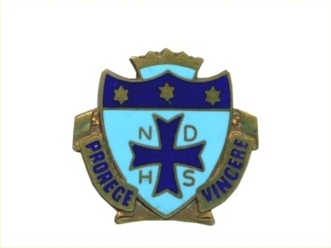

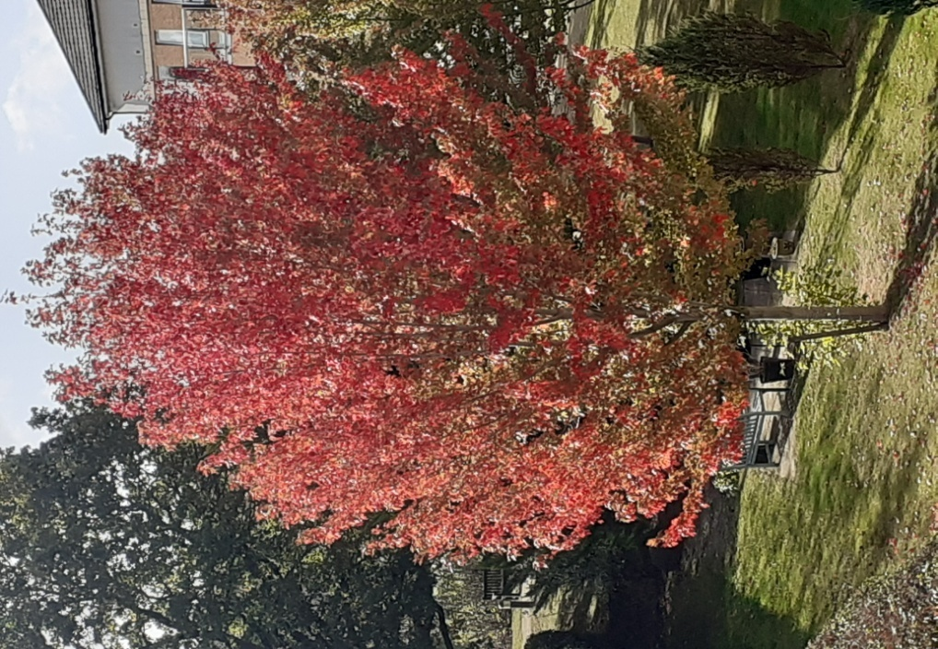
Without a doubt this summer has gone on and on and despite the fact that we had no rain for a number of months the trees still have all their leaves on in their glorious autumn shades.

A message from the BFNDA President Hilary Helm

On the next page is a report that has been sent to Liverpool, Manchester and to the Direct members. I want ALL Federation members to be quite clear on what I've done, why I've done it and who's going to benefit.

THE BFNDA PRESIDENT’S CHARITY REPORT 2026
Last year, just as St Julie’s News was being printed, I received information from the General Treasurer of Notre Dame, USA, who oversees the funding of projects in Africa. The Photovoltaic Project in the Kwango Province of D R Congo, which I had chosen as the President’s Charity, was complete. At the Weekend Away in 2025 we donated £5,000 pounds sterling to the Sisters of Notre Dame which would be used towards on-going maintenance funds e g purchasing replacement lithium–ion batteries for the electrical power generated as a result of the project. The Sisters of Notre Dame continue to work tirelessly in a number of African countries and their efforts are supported by the past pupils of the many Notre Dame Schools in North America and other countries throughout the world.
However, as far as I was concerned, the project was finished and I needed to find another Charity to support. Like those present for the AGM that year I had been very taken by the words of Sr Catherine Darby SND. She informed us that there are now ten schools in Great Britain, three in Scotland and seven in England and the Notre Dame Spirit is alive and active and being enabled through biennial leadership conferences for students.
This year Sr Catherine joined us once again in Leeds and spoke again about the need to support Catholic Youth within the UK so that they in turn could ‘go on sowing the good seed’ for the future. She went on to say that for a number of years, the Heads of the Notre Dame Schools in England and Scotland have come together for an annual networking conference. The students found out and said that they would like the opportunity to do the same! The first conference was hosted by the National Shrine of Our Lady in Walsingham and they were inspired by Mary as a young woman who was inspired to say 'yes' to her calling. The second conference was hosted by Buckfast Abbey, and they were inspired by the Rule of St Benedict “Listen carefully… and incline the ear of your heart.” Currently a third conference is being planned to take place at Savio House, a retreat centre run by the Salesians. Each school will send a group of 12-14 year olds to spend time together in prayer, conversation and friendship. They will reflect on the life and writings of St Julie and the hallmarks of SNDdeN. They will then consider how the experience will inspire them to lead on aspects of youth ministry back in their schools. Catherine went on to say that St Julie taught us we should 'go on sowing the good seed'. The Schools Conference is an invaluable way in which together as a community of schools we can carry on this mission.
I certainly felt inspired by Catherine’s words and going forward I would like to support the young people who currently attend Notre Dame schools and colleges. As I had no way of informing anyone of my decision to change my nominated charity it was agreed that of the £3,000.00 charity donation that has been raised in the last 12 months, £2,500.00 should still go to the Photovoltaic project for which it had been given, and that £500.00 should be sent to the Notre Dame Schools Leadership Conference.
As this is my third year as President of the BFNDA I sincerely hope that others like me feel inspired to support this project and will give generously throughout the year. In fact attendees at this year’s AGM clearly shared this view as an impromptu collection was made and raised £156.00.
There's a list of Notre Dame educational establishments in SJN 2025.

Our Christmas Social

Yes, it’s that time of the year again to book places for yourself and friends at the Christmas Social.

On: Friday 4th December
from 12.00 noon until 2.00pm

At: The Freemason’s Lodge
Sheaf Close
Harlestone Road
Northampton NN5 7UL

Cost: £10.00 per person

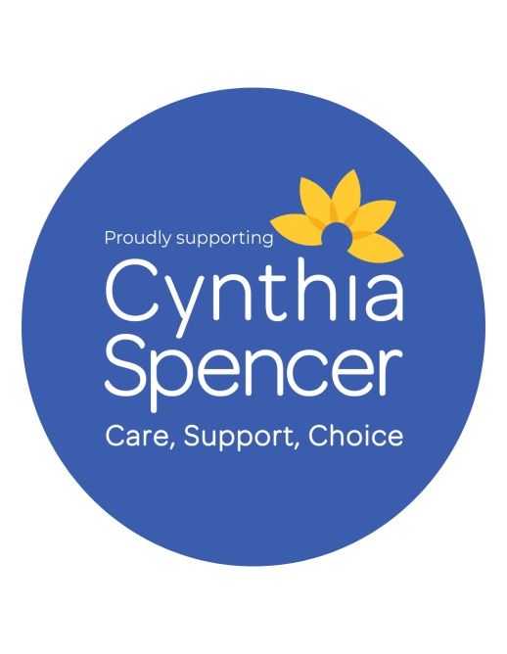
This year instead of us having a raffle The Cynthia Spencer Hospice Choir will be joining us to entertain with seasonal songs and carols.
The money you would spend on the raffle could be donated to the hospice appeal instead.

Please let us know by 20th November at the latest.

Our AGM & Luncheon next year will be held on Sunday 18th April at the Freemason’s Hall, Northampton.
Please remember to put the date into your new diary.

With our very best wishes to you all from the committee
Cathy, Celine, Hilary, Kathleen, MariAn, Marie and Pam

